

*Youth Offending Service*

|  |
| --- |
| **Team Around Child/Family Process TAC/TAF** |

|  |  |  |
| --- | --- | --- |
|  | Effective Date: |  |
|  | Document Author |  |

**Team Around the Child/Family (TAC/TAF) Planning and Review Meeting**

The Enfield YOS Team Around the Child/Family (TAC/TAF) Planning Meeting is crucial to ensure that there is effective planning of the intervention to be delivered. This section defines the appropriate TAC / TAF procedures.

If your family meets the Change and Challenge criteria and there are two or more other external agencies involved, they will need to be invited to a TAF meeting. YOS will need to ensure that the TAF is held on the same day as the TAC, one after the other.

**(i) Purpose of TAC / TAF Meetings:**

* To agree the initial 3-month intervention plan with the young person and their parent(s)
* To ensure the young person/parent(s) have an opportunity to give their views about the content, prioritisation and sequencing of actions in the intervention plan
* To ensure the young person/parent(s) are aware of the expectations regarding who they will see in the first 3 months and the rough schedule of when they will see them
* To ensure all YOS staff/partners who will have a significant input into the intervention within the coming 3 months are involved in the planning of this and are clear about their role/actions
* To ensure there is a coordinated approach to the delivery of the intervention

**(ii) Preparing for and booking the initial TAC / TAF planning meeting:**

* Pre-TAC meeting should be held 30mins-45mins before the TAC/TAF meeting takes place – subject to discussion with the rest of the managers/seniors and network. Please click below for guidance:



* The case manager is responsible for planning the TAC / TAF planning meeting with the Young person and their parents. A TAF meeting would need to take place prior to the TAC meeting on the same day if the family meets two+ of the criteria for Change and Challenge.
* The case manager will invite appropriate specialists based on the degree to which they will be involved in the intervention – If the Young person is subject to ISS, the ISS worker will always be invited to the TAC / TAF.
* TAC / TAF planning meetings should be booked to the following schedule: (i) YROs – within 15 working days of the start of the intervention; (ii) DTO Licences – within 15 working days of release; (iii) Referral Orders – within 15 working days.
* The Case Manager should provisionally book the TAC / TAF date with the Chair, Young person and their parents as soon as possible after sentence. It is likely that the Case Manager will have an idea of which specialists may need to attend from completion of the PSR even before specialist screenings/assessments have been completed. The case manager should inform relevant specialists of the provisional date for the TAC / TAF when making the referral.
* The Case Manager should consider how many people to invite to the TAC / TAF – it is likely that this will not exceed one or two specialists in addition to the case manager, the case manager will prioritise specialist attendance based on which staff are most significant to the intervention planning process.
* Once all assessments have been completed the Case Manager will confirm by email the date and time of the TAC / TAF and who is invited.
* If a specialist is unable to attend they should meet with the Case Manager before the TAC / TAF to agree how their work will be integrated into the intervention plan – including appropriate sequencing and scheduling of specific appointments.

(iii) **Running the initial TAC / TAF meeting:**

* The Line Manager (Chair) should complete introductions and explain the purpose of the TAC / TAF meeting. The Chair should then speak to the Young person and parent/guardian and ensure they understand the purpose of the meeting provide an opportunity for any comments.
* Chair to discuss the **Enfield YOS Compliance and Motivation Assessment (see Appendix 1)** document and ensure that all necessary considerations have been explored i.e. learning styles etc.
* Using the signs and safety model the Case manager will then discuss their assessment identifying what they feel is going well and not so well and the intervention work they would like to undertake in the first three months. Young person and Parent/guardian will then be offered the opportunity to comment on their views
* Any other specialist who is invited to the meeting will also be discussing the outcome of their screening and the work they would like to undertake. The Young person and parent/guardian should be given the opportunity to comment.
* Once the chair has agreed there is a consensus of what work will be taking place over the next three months. The chair and specialists will leave the room and the case manager; Young person and parent/guardian will then be given the opportunity to complete an outcome focused intervention plan: (**see** **Appendix 2**)

**Things that make me offend -** This section requires the Young person and case manager to identify the aspects in the child life that makes the offend. The case manager should help identify the ratings of these desistance factors to aid sequencing. Please click here for guidance: Case manager to bring desistance factors to the meeting to discuss with parent/YP and address in the YP’s intervention plan along with the changing circumstances section of Asset+.



**Things that could make me stop offending** **–** The Young person should identify things that will stop them from offending. Case manager should help them identify the rating of these desistance factors to aid sequencing

**Goals –** Young person and worker should record outcome focussed goals that will either reduce risk factors and/or strengthen protective factors. These goals need to be S.M.A.R.T

The rest of the boxes on the plan need to be completed and signed at the end by all parties.

* As part of agreeing the intervention plan the Case Manager should facilitate a discussion involving the Young person, parent(s) regarding which tasks are most important to achieve to reduce likelihood of reoffending, the order in which they should be achieved and when they should start . An **Enfield YOS Compliance and Motivation Assessment (see Appendix 1)** should - desistance factors from the ASSET have been completed by the case manager at the first appointment with the Young person to ensure they are identifying barriers to compliance and agreeing actions to support compliance. This document will need to be reviewed at this meeting.
* At the end of the TAC / TAF meeting the Case Manager should ask the Young person and parents to sign the plan template and a copy of this signed plan should be uploaded to CVYJ on the Young person’s intervention tab. A copy of the plan should be printed and given to the Young person and their parent(s) at the end of the meeting.
* The TAC / TAF meeting should also be used where appropriate to agree the outline schedule of contacts with YOS staff and external partners to meet the required National Standards contact levels and ensure there are no timetable clashes.
* As a final part of the meeting the Case Manager should indicate the provisional date for the TAC / TAF review and who should attend this review

(iv) **Follow up actions from initial TAC / TAF meeting:**

* Our intervention Plan in Pathways and Planning should be created or updated within 2 working days of the TAC / TAF meeting – The first line should state see attached Plan.
* The copy of the intervention plan created at the TAC / TAF meeting and signed by the Young person and their parent(s) should be saved in the Young person’s file and attached on CVYJ
* The Case Manager should record that a TAC / TAF had been held in the Key Process Box on the Young person’s intervention record and create a CVYJ contact and associated case diary entry specifying who had attended the TAC / TAF and any key issues
* Letter to YP/Parents confirming schedule of contacts as agreed at TAC / TAF – copies to all YOS staff/external partners

(v) **TAC / TAF Review Meetings**:

* The Line Manager will chair the Review of progress against the initial intervention plan (**see Appendix 3**). All professionals and Young person/parent/guardian will discuss the progression thus far.
* As before the Line manager and specialist will leave the meeting once there is a consensus of agreement of amended/additional actions (**see Appendix 2**)
* Cases which meet two+ Change and Challenge criteria would have a **TAF** review meeting taking place every six weeks. This update could take place in written form or verbally. Team Around the Family Signs of Success template (**see Appendix 5**) is to be used for TAF meetings.
* There should be an agreement on prioritising and sequencing of further intervention with the case manager, parent/guardian
* The case manager, young person and parent/guardian should then complete an outcome focussed plan of schedule for next 3 months **(use Appendix 2).**
* Date of next TAC / TAF review

(vi) **Final TAC/TAF Meetings:**

* If final review, complete the contingency planning column and ‘My Plan Final Review Closure’ template **(see Appendix 4)** YOS and YP will discuss progress on order and agree any ongoing referrals, actions needed to sustain progress; exit strategies and the completion of Snap Survey.



*Youth Offending Service*

Appendix 1

**ENFIELD YOS COMPLIANCE AND MOTIVATION ASSESSMENT**

|  |  |
| --- | --- |
| **ISSUES TO COVER THAT MIGHT IMPACT ON COMPLIANCE** | |
| **SCHOOL, COLLEGE, TRAINING OR WORK ISSUES** | |
| * Attendance at school, college, training or work – record times when not available | |
| * Regular overtime or unpredictable work patterns | |
| * Other school/college/training related commitments or activity (e.g. after school group) | |
| * Value in linking YOS appointments to school, college, work | |
| **PERSONAL, FAMILY OR LOCAL COMMUNITY ISSUES** | |
| * Motivation of Young person including previous history of compliance | |
| * Health issues that might impact on attendance and participation | |
| * Drug/alcohol issues that might impact on attendance and participation | |
| * Young person’s routine and possible impact on attending YOS (e.g. time YP gets up) | |
| * Childcare arrangements or need to look after family member | |
| * Commitments associated with religious/cultural beliefs | |
| * Involvement in community activities or other community commitments | |
| * Gang/peer association issues that will impact on attendance at YOS | |
| * Support from family to keep YOS appointments | |
| **TRANSPORT ISSUES** | |
| * Likely method of transport for getting to YOS on a regular basis | |
| * Ways of ensuring finance is available to pay for public transport | |
| **SUMMARY OF SIGNIFICANT COMPLIANCE ISSUES, TIMES TO AVOID AND POSSIBLE SOLUTIONS FOR COMPLIANCE AGREEMENT** | |
|  | |
| **SUPPORT FOR ATTENDING APPOINTMENTS – Which of the following will help to keep appointments** | |
| Appointments at same day and time each week where possible |  |
| Booking several appointments in advance |  |
| Booking more than one appointment on the same day |  |
| Confirming appointments by text |  |
| Reminding parents of appointments |  |
| Any other ideas from the Young person/parent(s) |  |
| **Comments including confirmation of contact details – phone/email/family phone etc to support attendance:** | |
| **AGREED ACTIONS TO BE INCLUDED IN COMPLIANCE AGREEMENT** | |
| 1) | |
| 2) | |
| 3) | |
| 4) | |
| 5) | |

**MY PLAN — [NAME OF ORDER] CONTRACT— INITIAL**

**1**

**Goal:**

**To do this I will:**

**How will I know when I’m doing well?**

**Goal:**

**Goal:**

**Goal:**

**To do this I will:**

**How will I know when I’m doing well?**

**To do this I will:**

**How will I know when I’m doing well?**

**To do this I will:**

**How will I know when I’m doing well?**

**Things that make me offend:**

**Things that could help me stop offending:**

**How will my parent/guardian help:**

**How will YJS and others help:**

I will try and do this by:

I will try and do this by:

I will try and do this by:

I will try and do this by:

I will complete reparation sessions I will complete at least one session on: Healthy relationships Knife Crime I will also see the YJS Nurse (Y/N)

**NAME:**

**NAME OF YJS WORKER:**

**DATE OF PLAN:**

**COMPLETION DATE:**

**2**

**2**

**Who else attended the meeting:**



**IF I HAVE A PROBLEM WHO CAN HELP ME ?**

**Future Review Dates:**



**HOW I LEARN BEST?**

**I will have at least ­­______appointments per month (minimum) that I must attend:**

**Signature YOSng person: Signature parent/guardian:**

**Name (Print) Name (Print)**

**Date: Date:**

**Signature Worker: Signature Panel Member:**

**Name (Print): Name (Print):**

**Date: Planning Meeting Date: _­­­­_____________ Review Date: _______________**



**WHAT WILL HELP ME STICK TO MY PLAN?**

**Thinking about the victim(s) what will I do to make things right**

**Further goals to consider:**

**Anything else I like doing or would like to try:**

My hopes for the future:

**NAME:**

**NAME OF YJS WORKER:**

**DATE OF PLAN:**

**COMPLETION DATE:**

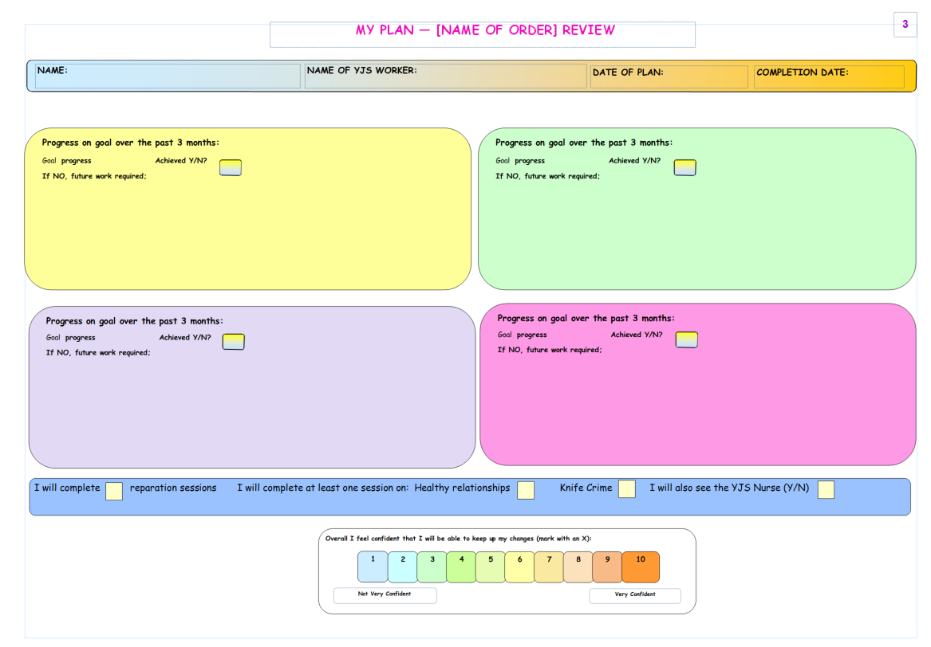

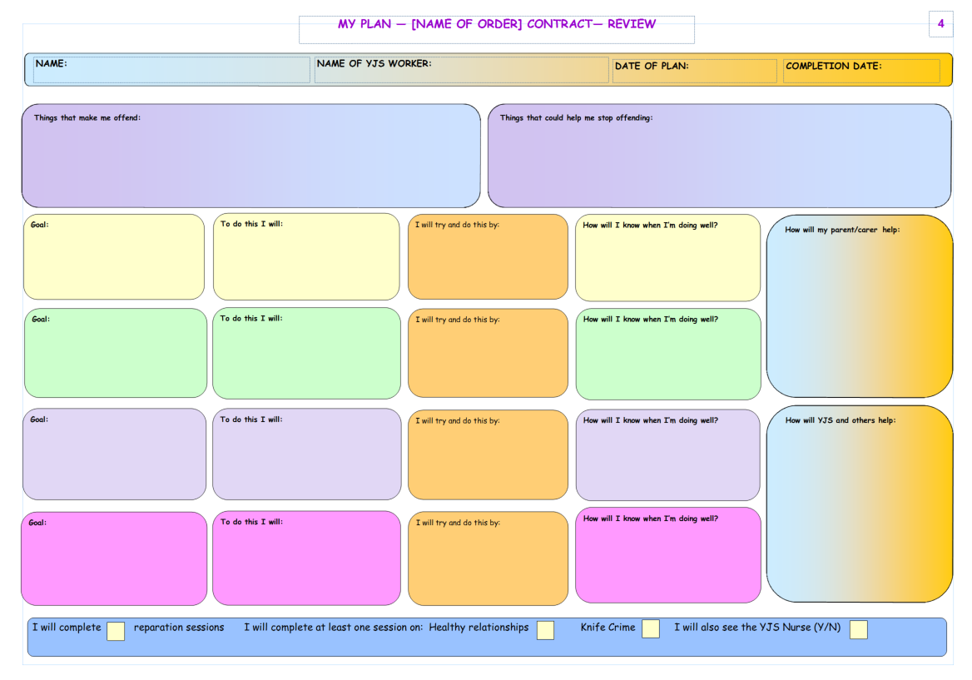

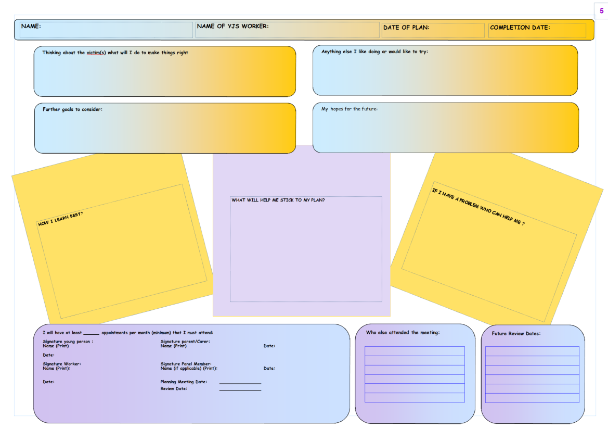

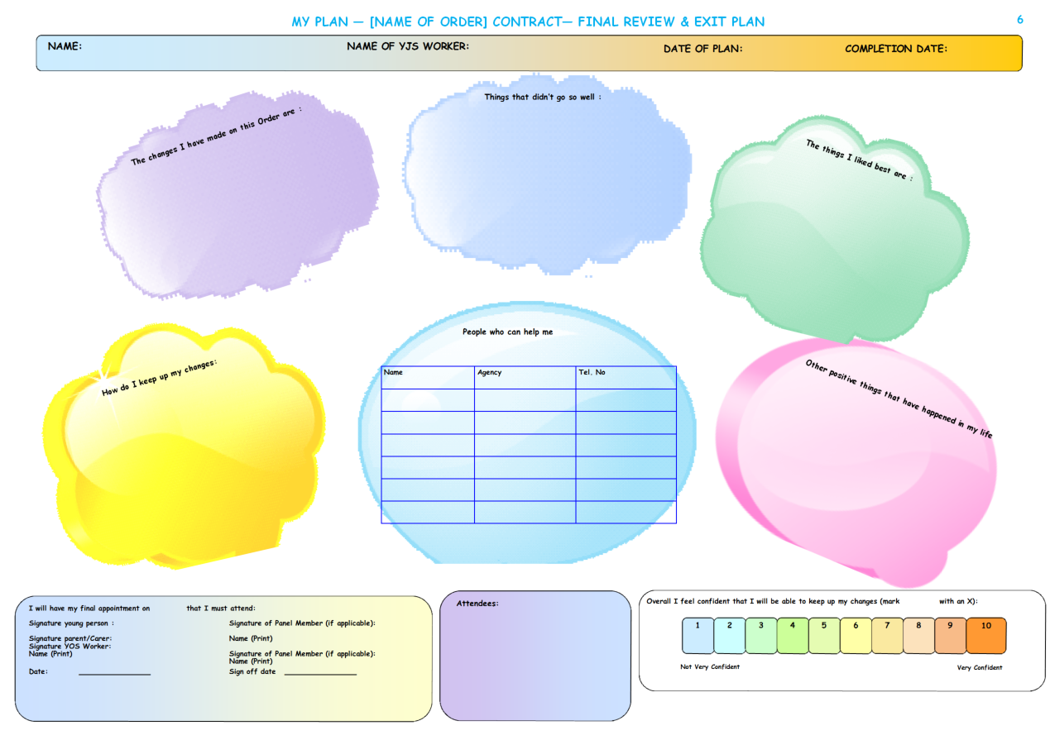

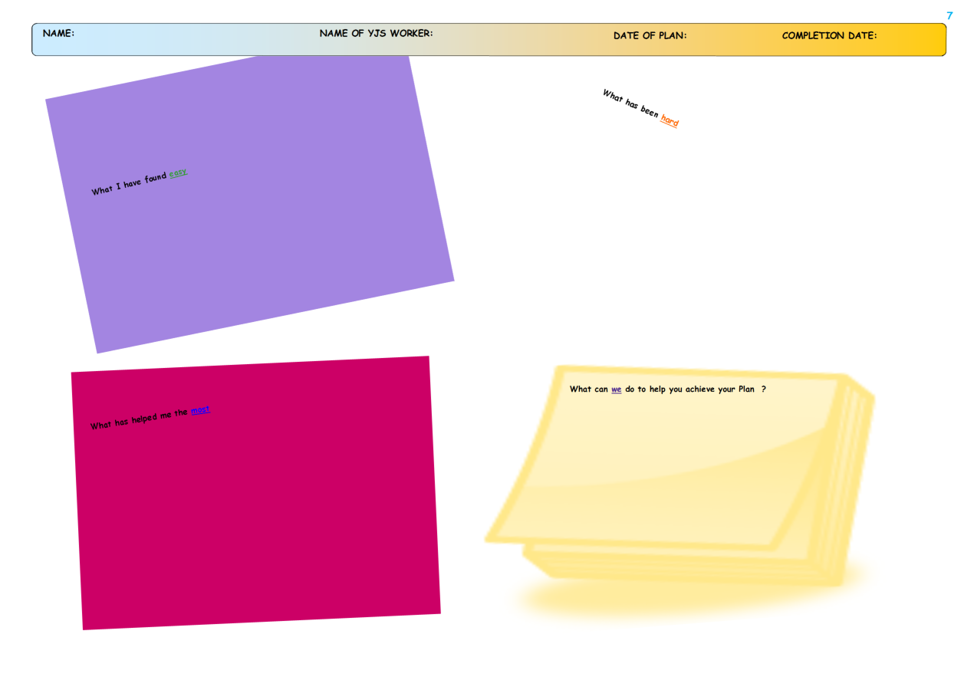

Appendix 5

Team around Family / Child Meeting

Initial / Review / Final

Date:

Venue:

**Confidentiality statement:**

This meeting is confidential, and the discussion and information shared is restricted to parties present, unless there is an agreement from the chair to do otherwise. This meeting is closed under the Freedom of Information Act 2000 under one or more of the following exceptions:

The Youth Offending Service work to prevent offending and re-offending of children and young people under the age of 18. As such we formally request that agencies disclose any relevant information which would be of assistance to us under Section 115 of the 1998 Crime and Disorder Act.

Our request for information is consistent with the provisions of Section 115 of the 1998 Crime and Disorder Act which places an obligation on public agencies to exchange information for the purposes of crime prevention and/or anti-social behaviour. This information will not be used in any way to contravene the General Data Protection Regulation (GDPR) 2018 Framework.

All information is treated in the strictest of confidence & is stored confidentially in order to protect against loss or unauthorised access. Creating ways to work positively with young people and their families/ carers remains our priority.

Investigations and proceedings by public authorities (s.30 (1) (B)

Health and Safety (s.39)

Personal Information (s.40)

Information provided in confidence (s.41)

**Diversity Statement:**

This meeting will aim to reflect that all individuals who are discussed at this meeting should be treated fairly, with respect and without improper discrimination. All work undertaken at the meetings will be informed by a commitment to equal opportunities and effective practice in relation to race, gender, sexuality and disability.

Attendees (by signing YOS agree to confidentiality / diversity statement):

|  |  |  |  |
| --- | --- | --- | --- |
| **Name** | **Role** | **Agency** | **Signature** |
|  |  |  |  |
|  |  |  |  |
|  |  |  |  |
|  |  |  |  |
|  |  |  |  |
|  |  |  |  |

Appendix 5

|  |  |  |  |  |
| --- | --- | --- | --- | --- |
| **Team around the child / family meeting tool**  (Professional’s view boxes are to be completed at the Pre-TAC/TAF meeting) | | | | |
| **Areas to Consider** | **What are we worried About?** | **What’s Working Well?** | **Contingency planning: What Needs to Happen/change?** | **Exit planning**  **(complete when commencing final TAC/TAF)** |
| **Goals & Opportunities** |  |  |  |  |
| **Professional’s view** |  |  |  |  |
| **Young person’s view** |  |  |  |  |
| **Parent’s view** |  |  |  |  |
| **Not Offending** |  |  |  |  |
| **Professional’s view** |  |  |  |  |
| **Young person’s view** |  |  |  |  |
| **Parent’s view** |  |  |  |  |
| **Not Hurting Others** |  |  |  |  |
| **Professional’s view** |  |  |  |  |
| **Young person’s view** |  |  |  |  |
| **Parent’s view** |  |  |  |  |
| **Keeping Safe** |  |  |  |  |
| **Professional’s view** |  |  |  |  |
| **Young person’s view** |  |  |  |  |
| **Parent’s view** |  |  |  |  |
| **Repairing Harm** |  |  |  |  |
| **Professional’s view** |  |  |  |  |
| **Young person’s view** |  |  |  |  |
| **Parent’s view** |  |  |  |  |
| **Any other comments?** |  |  |  |  |
| **Professional’s view** |  |  |  |  |
| **Young person’s view** |  |  |  |  |
| **Parent’s view** |  |  |  |  |
| **Success Scale: On a scale of 0 to 10 where 10 means your life is ‘on track’ to get where you want to go in life and 0 your life needs to change, you are not on track.** | | | | |
| **Young person’s views:** | | | | |
| **Parent’s views:** | | | | |
| **Where do you want to be?** | | | | |
| **Working Relationships Scale: On a scale of 0 to 10 where 10 means that you would like to work with the YOS to complete your interventions and 0 means that you do not want to work with the YOS?** | | | | |
| **Young person’s view:** | | | | |
| **Parent’s view:** | | | | |

|  |  |  |
| --- | --- | --- |
| **Date:** | **Time:** | **Venue:** |
|  |  |  |

**Lead agency:**

**Next review:**