|  |
| --- |
|  |
| *Youth Justice Service* | |
| |  | | --- | | **Helpful documents to aid recording on CVYJ (Child View Youth Justice)**  **And**  **Where, when, and how to upload documents** |  |  |  |  | | --- | --- | --- | |  | Effective Date: | 14/12/2020 | |  | Last Reviewed: | 16/08/2022 | | |

|  |  |  |
| --- | --- | --- |
|  | Document Author: | Claire Griggs, Intelligence & Business Support Lead |

**This document needs to be read in conjunction with the Case Recording Protocol which provides the principles of case recording and expectations.**

Although there are several documents provided by CACI for guidance for recording on CVYJ there are also several in house documents available to also assist staff in recording. Which are linked into this document for ease.

All documents pertaining to recording and linked in this document can be found:

**R:\Social\YOS\1. INDUCTION FOLDER\CVYJ – Recording**

**CACI Case Guidance**

CACI have provided a full guide coving all aspects of the application and some extra advice notices which are linked below for reference:

* CVYJ Guidance
* Advice Notices

**Updating Address’s Out of Borough**

Most addresses within the Borough of Enfield are on CVYJ, however there are some new builds always being developed and out of area address that are not in the system. These can be added to the address book by following the below guidance – alternatively if you do not feel confident in this you can email the court team with the details.

* Updating Address’s Guidance

**Cap Area Recording**

The borough is divided into 4 cap areas, information is gathered by cap area.

* Area Recording

**Event Characteristics**

Event characteristics are recorded under the detail’s region off CVYJ – these event characteristics trigger the Icons for any Risk, Vulnerability or Local Identified. Below is the list of characteristics and the icons that they trigger:

* Event Characteristic List

**Pre-Court Screen**

Pre Court Screen is updated primarily by the court team but the OOCD team need to update following a Triage outcome by panel or when the YC or YCC is signed.

* Pre Court Recording

**Referral Screen**

Referrals are usually triggered through the asset plus flags for action section. Case Workers and specialists have a responsibility to ensure that these are completed and updated. Further information can be found under the referral guidance document.

* Referral Guidance

**Asset Plus**

There are 2 documents to assist with recording in this section provided by CACI and YJB.

* YJB Assetplus Guidance
* CACI Assetplus Guidance

**Contacts**

There is specific options that are required to be used for specific contacts these are listed in the codes – contact document. There is also some guidance on amending workers, scheduling appointments in the contact recording document.

* Contact Recording
* Codes – Contact

**Enforcement**

There are several documents to assist with the recording of enforcement. There are different processes depending on the order the YP is on.

* Enforcement Recording

**Key Process (Intervention Region)**

Key process should be completed for specific actions. There is a list of the process available and also guidance on when to use them.

* Key Process Options
* Key Process Guidance

**Education**

The education screen is split into different sections depending on if they are at school or if they are above school age. The below is guidance on where to record what within this section.

* ETE Screen Guidance

**LAC, CIN, CP**

This information entered will trigger the icons. To ensure that this information is recorded, and the icons triggered please use the guidance below for assistance.

* LAC, CIN and CP Recording

**Creating Parents**

Case Workers are required to create and link the parents in order to have the information available which will pull through to asset plus.

* Creating Parent and Assetplus Guidance

**Victim Information**

Information pertaining to victims is protected and can only be viewed by those that have been granted permission. The below document is guidance from CACI in recording this specific information.

* Childview Victim Recording

**Group Information**

Group information is updated by the Serious Youth Justice Officer. Information needs to be shared with this worker for the system to be updated. The system will use this information to provide the conflicts information for appointments. Document below is provided from CACI

* CACI – Group Recording Guidance

Uploading documents to CVYJ.

All documents that pertain to a young person must be uploaded to CVYJ. The following is guidance on where the individual documents should be saved to assist a universal approach within the service and for ease of obtaining information for any staff member.

Most documents will be uploaded to the notes and attachments sections of specific regions with in CVYJ.

Specific documents should be grouped under one heading in the intervention page. Please see page 3 for instructions.

**Case Workers**

|  |  |  |  |
| --- | --- | --- | --- |
| Document Name | Where document is to be saved | Time frame for upload | Who should save document |
| CPS Documents | Offences Region | Upon receipt | Court Team |
| Court Appearance Sheets | Court Region | When screen is updated | Court Team |
| Court Orders | Court Region | Upon receipt | Court Team |
| MG3’S – OOCD | Pre-Court Region | When screen is updated | Court Team |
| Referral for and OOCD | Court Region | When screen is updated | Court Team |
| Section 10 Statement | Court Region | When screen is updated | Court Team |
| YC and YCC Signings | Intervention Region | 24 hrs of signing | Case Worker |
| Specialists Screening Tools | Under the Specialists Referral Screen | 24 hrs of Completion | Specialist |
| ISS Screening Tool |  | 24 hrs of completion | Specialist |
| Resettlement Screening Tool | Intervention Region | 24 hrs of completion | Specialist |
| Resettlement Plan | Intervention Region | 24 hrs of completion | Specialist |
| Pre-Attitudinal Surveys | Under the Specialists Referral Screen | 24 hrs of completion | Specialist |
| Post-Attitudinal Surveys | Under the Specialists Referral Screen | 24 hrs of completion | Specialist |
| Social Care Reports | Legal Tab | 24 hrs of receipt | Case Worker |
| Secondary Checks | Assessment Region – Post Court  Intervention – Pre-Court | 10 days from Requests | Case Worker |
| Medical Form (Reparation) | Documents Tab | 24 hrs of YP completing | Reparation officer & Referral order officer |
| Reparation Feedback | Intervention Region | Next working day | Reparation officer & Referral order officer |
| Specialist Intervention Work | Intervention Region | 24 hrs of completion | Specialist |
| Young Persons Plan | Intervention Region | 24 hrs of completion | Case Worker |
| PSR Gate Keeping Forms | Report Region | 24 hrs of completion | Operations Manager |
| PSR | Report Region | 24 hrs of completion | Case Worker |
| Breach Reports | Report Region | 24 hrs of completion | Case Worker |
| Panel Reports – all documents | Intervention Region | 24 hrs of completion | Case Worker |
| Assetplus Gate Keeping Forms | Assessment Region | 24 hrs of completion | Operations Manager |
| Supervision Actions | Intervention Region | 24 hrs from Meeting | Operations Manager |
| Appointment Letters | Intervention Region | 24 hrs of Sending | Case Worker / Specialist |
| Warning Letters | Intervention Region | By end of the day issued | Case Worker |
| Social Care Plans (CIN/LAC/CP) | Legal Region | 24 hrs of receipt | Case Worker |
| EHCP | Health Region | 24 hrs of receipt | Case Worker / Ed Psych |
| File Audits | Intervention Region | 24 hrs of receipt | Business Support |
| Compliance Meetings | Intervention Region | By end of day | Chair of Meeting |
| Mappa Forms | Referral Region |  | Case Worker |
| TAC / TAF Chair | Intervention Region | By end of day of meeting | Operations / Senior Manager |
| Behaviour Contract | Intervention Region | 24 hrs of signing | Case Worker |
| Notice of Supervision (Custody) | Intervention Region | 24 hrs of receipt | Case Worker |
| MALRAP (If relevant) | Intervention Region |  | Case Worker |
| Learning Style Questionnaire | Intervention Region | 24 hrs of completing | Case Worker |
| T1 Form (Custody Cases) | Intervention Region | 24 hrs of receipt | Case Worker |
| Letter of Explanation | Intervention Region | 24 hrs of completion | Victims Worker |
| Risk assessment for RJ Meetings / Mediation | Intervention Region | 24 hrs of completion | Victims Worker |
| Victim Feedback questionnaire | Victims Profile | 24 hrs of completion | Victims Worker |
| Transition Plans (Probation) | Intervention Tab | 24 hrs of completion | Case Worker |
| Need to Know | Intervention Tab | Uploaded following email to senior management | Operations / Senior Manager |
| MACE Referrals | Under Specialists Referral Screen | 24 hrs of completion | Case Worker |
| GPG Referrals | Under specialists Referral Screen | 24 hrs of completion | Specialist Worker |
| Young People’s court feedback form @ Enfield YC | Court Region | When screen is updated | Court Team |
| Parents Court feedback form @ Enfield YC | Court Region | When screen is updated | Court Team |
| ISS Timetable | Intervention Region | 24 hrs of signing | ISS Officer / Case Worker |
| YP Self-Assessment (Initial, Reviews, Ends) | Attach in assetplus section  Cases where assetplus is not created – Attach to intervention | Within 24 hrs of receiving email from Business Support Team | Case Worker |
| Parents Self-Assessment | Attach in assetplus section  Cases where assetplus is not created – Attach to intervention | Within 24 hrs of receiving email from Business Support Team | Case Worker |

**Grouping Documents in CVYJ.**

As there are several documents that are required to be attached to the Intervention notes and attachments – it is requested that documents are grouped together. Below is an example:

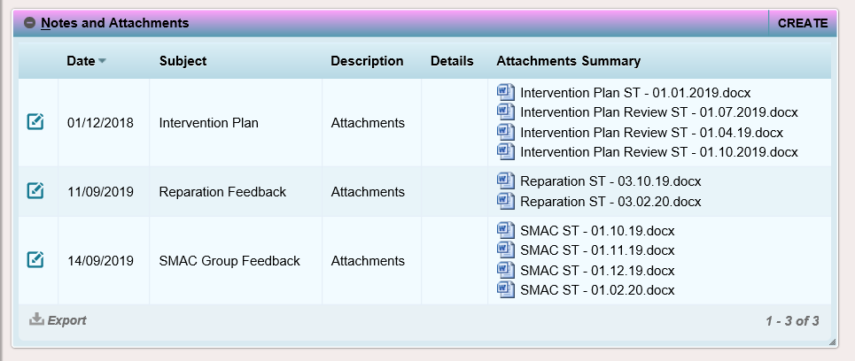

In order to attached documents as above:

Click on create on the notes and attachments region of the intervention page.



Date = First Date of meeting / activity

Description = Attachments

Subject = What are the documents that you are attaching i.s Intervention Plan, Reparation, Mental Health work etc

Attachment add the document that you want to upload.

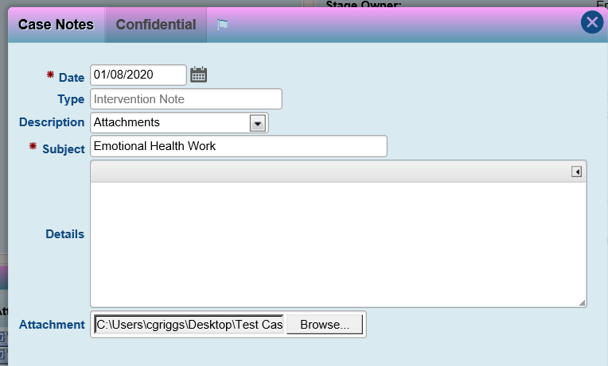

Click the save button.

**Adding further documents to the group.**

To add any further documents in relation to the specific group.

Click on the edit button to the left of the specific group you want to add document to.

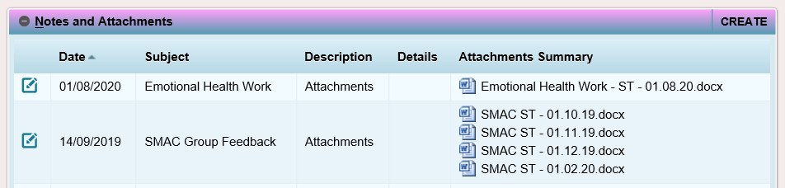

Click on the browse button and attached the document as required.