Practice guidance Note

Title: | Young Carers Assessment Process

Who is it for?
Children and Family Services Teams – All of children services
When is it in effect from?
Monday 1st July
What is it in response to?
Data analysis has revealed that young carers are not being identified on children services records. This limits the identification of young carers for reporting purposes and could mean that some young carers are not accessing services which may promote their welfare.
This guidance will allow for young carers to be identified, assessed and provided with the appropriate support services.

What is its purpose
To clarify expectations for identifying and assessing the needs of young carers within an assessment.

What does it amend/or replace?
N/A
Practice Guidance Note
Definition of a Young Carer:

- Aged 25 and under,
- Cares for family member who cannot cope without support due to illness, disability, mental health, addiction

Legal responsibility:

Young Carers (Needs Assessments) Regulations 2015 state that:

- The Local Authority must take ‘reasonable steps’ to identify children who are young carers
- The Local Authority must carry out an assessment if it appears that the Young Carer is in need of support

Assessments:

Young Carer assessment should be considered for all children in the household and included within any assessment undertaken with children (i.e., Child &Family Assessments, Early Help Assessment and Asset plus).
When undertaking an assessment, the Assessor should pay particular attention to:

- The young carer's age, understanding and family circumstances
- The wishes, feelings, and preferences of the young carer
- The caring tasks the young carer is carrying out
- The impact being a young carer is having on the young person’s mental and physical health
- Any differences of opinion between the young carer, the young carer's parents and the person cared for, with respect to the care which the young carer provides
- The outcomes the young carer seeks from the assessment

The following link provides further guidance on best practise for assessing children as young carers.

- Working together to support young carers and their families

The following screening tools should be used to inform your assessments and recommendations. These are designed to assess the amount of caring activities being carried out and provide a view on the emotional impact of caring:

- Multidimensional Assessment of Caring Activity (MACA-YC18)
- Positive and Negative Outcomes of Caring (PANOC-YC20)

These tools can be found in the following link:

- Young carers - assessment tools - Social Workers Toolbox

When child/ren are identified as a young carer at the end of a child & family assessment, the young carer factor should be ticked as ‘yes’ within the assessment as illustrated in the following screen shot:

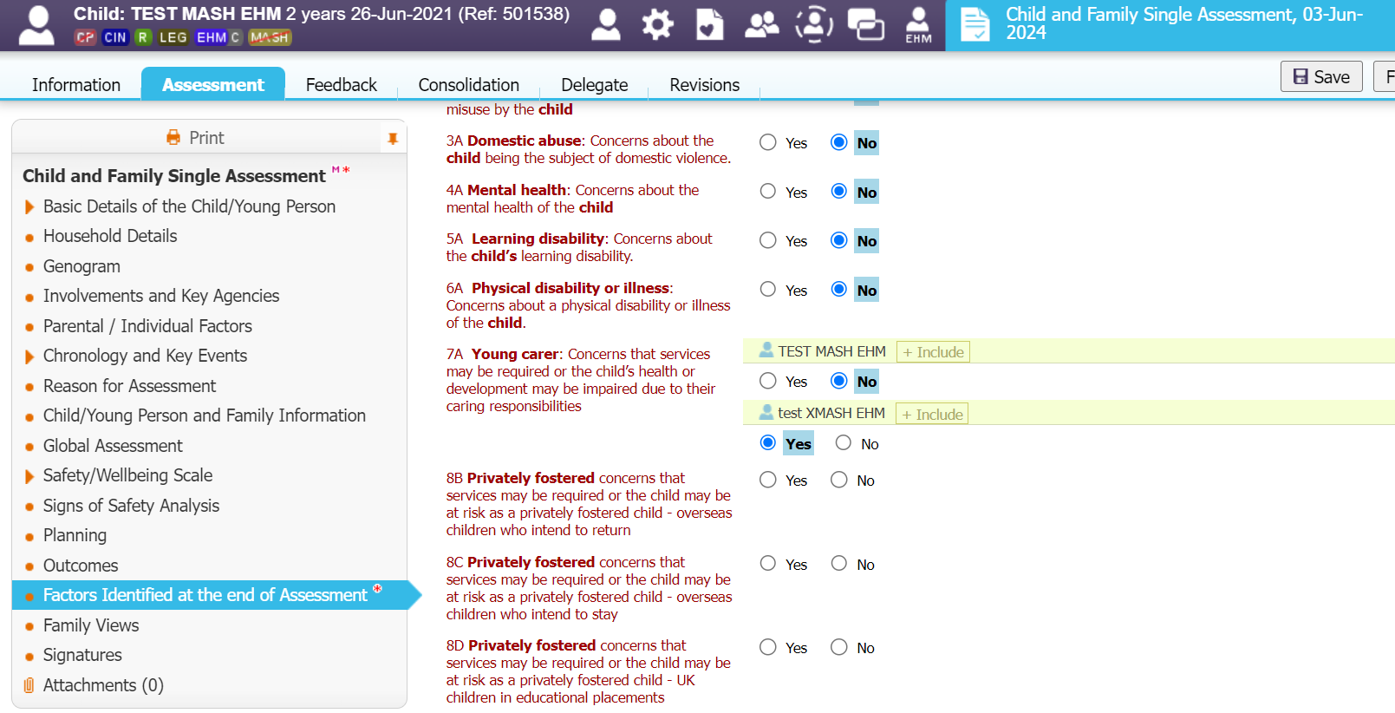

All young carers must also be identified in the relationship tab for EHM/LCS as illustrated in the following screenshots:

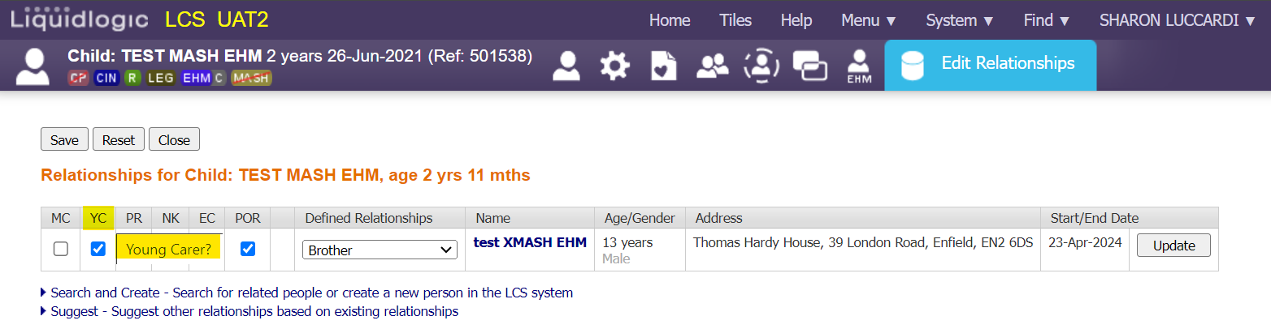

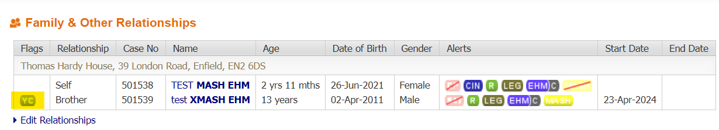

Once a child has been assessed as a Young Carer, the child should be offered support in line with their expressed wishes and feelings. Access to information on support available to young carers in Enfield is available via the Early Help Directory:

https://enfielddirectory4all.co.uk

Name of person/s issuing this practice note: | Joseph Fitzgerald, Service Manager, Early Help and Linda Read, Service Manager, Assessment & Intervention.
Date issued: | 24.06.2024
Version Control | V1
Authorisation by whom and date | OMG 08-08-24.

